AIoT Homework 2
B1228021 Chiu Ting-Yu
1. Overview
Building on Homework 1 (Q-Learning), this homework implements a Deep Q-Network (DQN) for the same Smart Greenhouse MDP, then systematically compares both algorithms in terms of training trend, convergence speed, final performance, and policy quality. The same environment, reward function, and epsilon-decay schedule are used for a fair comparison.

2. Motivation for DQN
Tabular Q-Learning has fundamental limitations that DQN addresses:
Limitation | Q-Learning | DQN Solution
State space size | Scales poorly (27 → 729 with 2 extra sensors) | Neural network scales gracefully
Continuous states | Requires manual discretisation (info loss) | Accepts raw sensor values directly
Generalisation | Each state learned independently | Similar states share weights
Convergence stability | Simple α update, may oscillate | Target network + replay buffer

3. DQN Implementation
3.1 State Encoding
State variables (moisture, temperature, sunlight) ∈ {0,1,2}³ are encoded as a 9-dimensional one-hot vector. This preserves the categorical structure and prevents the network from falsely interpreting bin indices as ordinal distances.
3.2 Neural Network Architecture
The Q-network approximates Q(s, a; θ) for all 7 actions simultaneously:
Layer | Size | Activation | Purpose
Input | 9 nodes | — | One-hot encoded state
Hidden 1 | 64 nodes | ReLU | Non-linear feature extraction
Hidden 2 | 64 nodes | ReLU | Higher-level representation
Output | 7 nodes | None (linear) | Q-value per action
Two hidden layers of 64 nodes provide sufficient capacity for the 27-state, 7-action problem without overfitting. The linear output layer allows Q-values to be any real number (positive or negative), unlike softmax which would distort the value estimates.

3.3 Key DQN Innovations
3.3.1 Experience Replay Buffer
A circular buffer stores the last 10,000 transitions (s, a, r, s′, done). At each training step, a random mini-batch of 64 transitions is sampled.
$$Buffer capacity : 10,000 transitions$$
$$Batch size : 64$$
$$Sampling : Uniform random (no prioritisation)$$
Why? Consecutive environment steps are highly correlated (same episode, similar states). Training on correlated data causes the neural network to oscillate or diverge. Random mini-batch sampling breaks temporal correlations, producing near-i.i.d. gradients.
3.3.2 Fixed Target Network
Two identical networks are maintained: a policy network θ (updated every step) and a target network θ⁻ (frozen, copied from θ every 200 gradient steps).
$$Bellman target: y = r + γ · max_\{a'\} Q(s', a'; θ⁻) ← uses FROZEN θ⁻$$
$$Loss: L(θ) = E[ (Q(s,a;θ) - y)² ]$$
$$Update: θ ← θ - lr · ∇L(θ) ← updates ONLINE θ$$
$$Sync (every 200 steps): θ⁻ ← θ$$
Without the target network, both sides of the Bellman equation change simultaneously, creating a moving-target problem. The fixed θ⁻ provides a stable regression target for 200 steps, preventing divergence.
3.3.3 Gradient Clipping
Rare high-reward transitions can produce very large Bellman errors and exploding gradients. Clipping the gradient norm to 10.0 prevents a single outlier from destabilising the network.
3.4 Hyperparameters
Parameter | Value | Justification
Learning rate | 0.001 (Adam) | Standard for Adam; smaller than QL due to NN sensitivity
Discount factor γ | 0.9 | Same as Q-Learning for fair comparison
Epsilon start / decay / min | 1.0 / 0.9995 / 0.01 | Same schedule as Q-Learning
Batch size | 64 | Balances gradient quality and training speed
Replay buffer capacity | 10,000 | ~500 episodes; diverse training samples
Target network update freq | 200 steps | Stable targets; current enough to learn
Hidden layer size | 64 × 2 | Sufficient for 27-state, 7-action problem
Gradient clip norm | 10.0 | Conservative; prevents explosion
Training episodes | 8,000 | Same as Q-Learning
Device | MPS (Apple Silicon) | GPU acceleration for faster training

3.5 DQN Training Algorithm
$$Initialize policy net Q(·;θ), target net Q(·;θ⁻)←θ, buffer B$$
$$For each episode:$$
$$s ← env.reset(); x ← one_hot(s)$$
$$For each step:$$
$$a ← ε-greedy(x, θ)$$
$$s', r, done ← env.step(a); x' ← one_hot(s')$$
$$Push (x, a, r, x', done) → B$$
$$Sample batch \{(xⱼ, aⱼ, rⱼ, x'ⱼ, dⱼ)\} from B$$
$$yⱼ = rⱼ + γ·max_\{a'\} Q(x'ⱼ,a';θ⁻)·(1-dⱼ)$$
$$L = (1/N) Σ (Q(xⱼ,aⱼ;θ) - yⱼ)²$$
$$θ ← Adam(θ, ∇L); clip ‖∇‖ ≤ 10$$
$$if step \% 200 == 0: θ⁻ ← θ$$
$$ε ← max(ε_min, ε × 0.9995)$$

4. DQN Training Results
4.1 Training Reward Curve
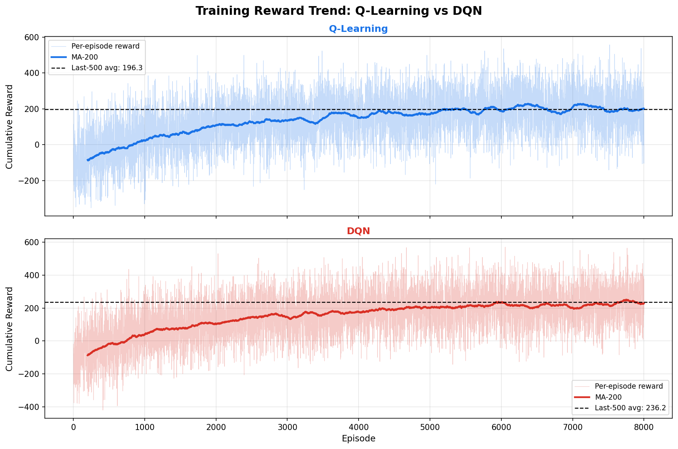
Figure 1. Training reward curves: Q-Learning (top) vs DQN (bottom) over 8,000 episodes.
4.2 DQN Training Loss
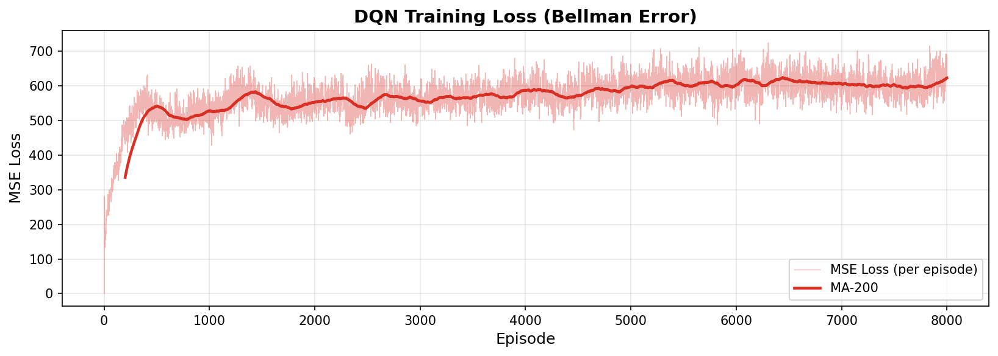
Figure 2. DQN MSE loss (Bellman error) over 8,000 training episodes.
The loss curve shows three phases:
- Episodes 1–1,000: Near-zero (buffer too small; no learning yet).
- Episodes 1,000–4,000: Rising loss as the network discovers higher Q-values.
- Episodes 4,000–8,000: Stabilisation around 600–650 MSE.
Rising loss does not indicate failure — it reflects the network assigning increasingly accurate (larger absolute) Q-values as it learns long-term rewards.
5. Q-Learning vs DQN Comparison
5.1 Training Trend Comparison
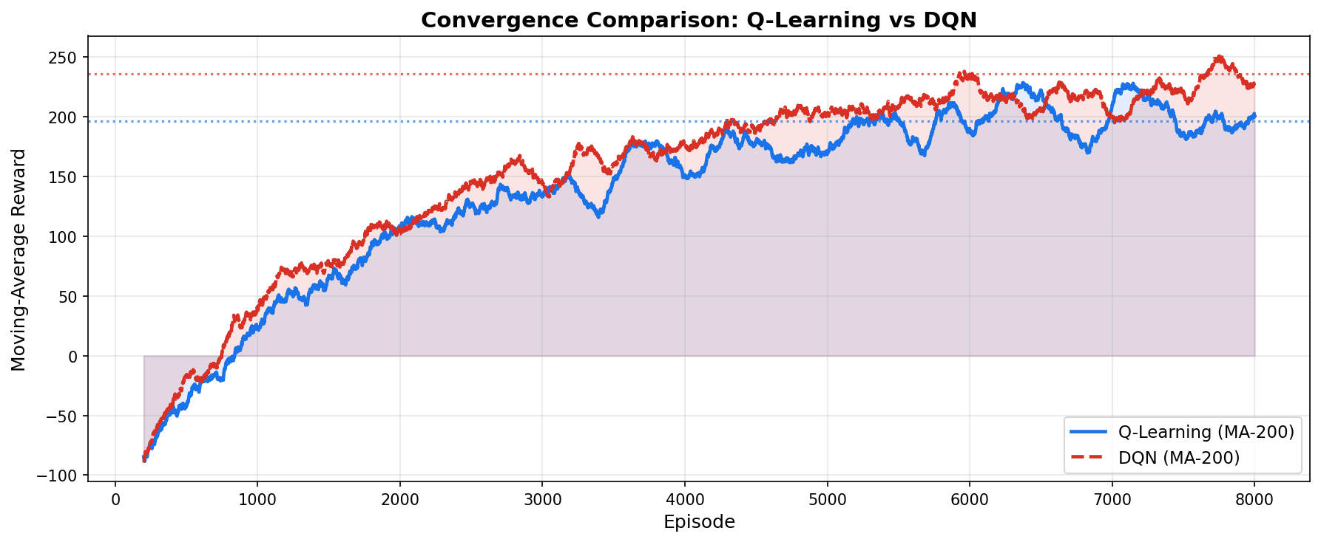
Figure 3. Smoothed (MA-200) reward overlay: Q-Learning vs DQN.
Key observations from the convergence overlay:
Training Phase | Q-Learning | DQN
Ep 1–1,000 | Fast rise (Q-table updated immediately) | Negative reward (buffer warm-up)
Ep 1,000–3,000 | Plateau ~100–150 | Rapid catch-up; surpasses Q-Learning
Ep 3,000–6,000 | Stable 150–200 | Steady climb 150→220
Ep 6,000–8,000 | Final avg ≈ 196 | Final avg ≈ 236

5.2 Test Performance Comparison
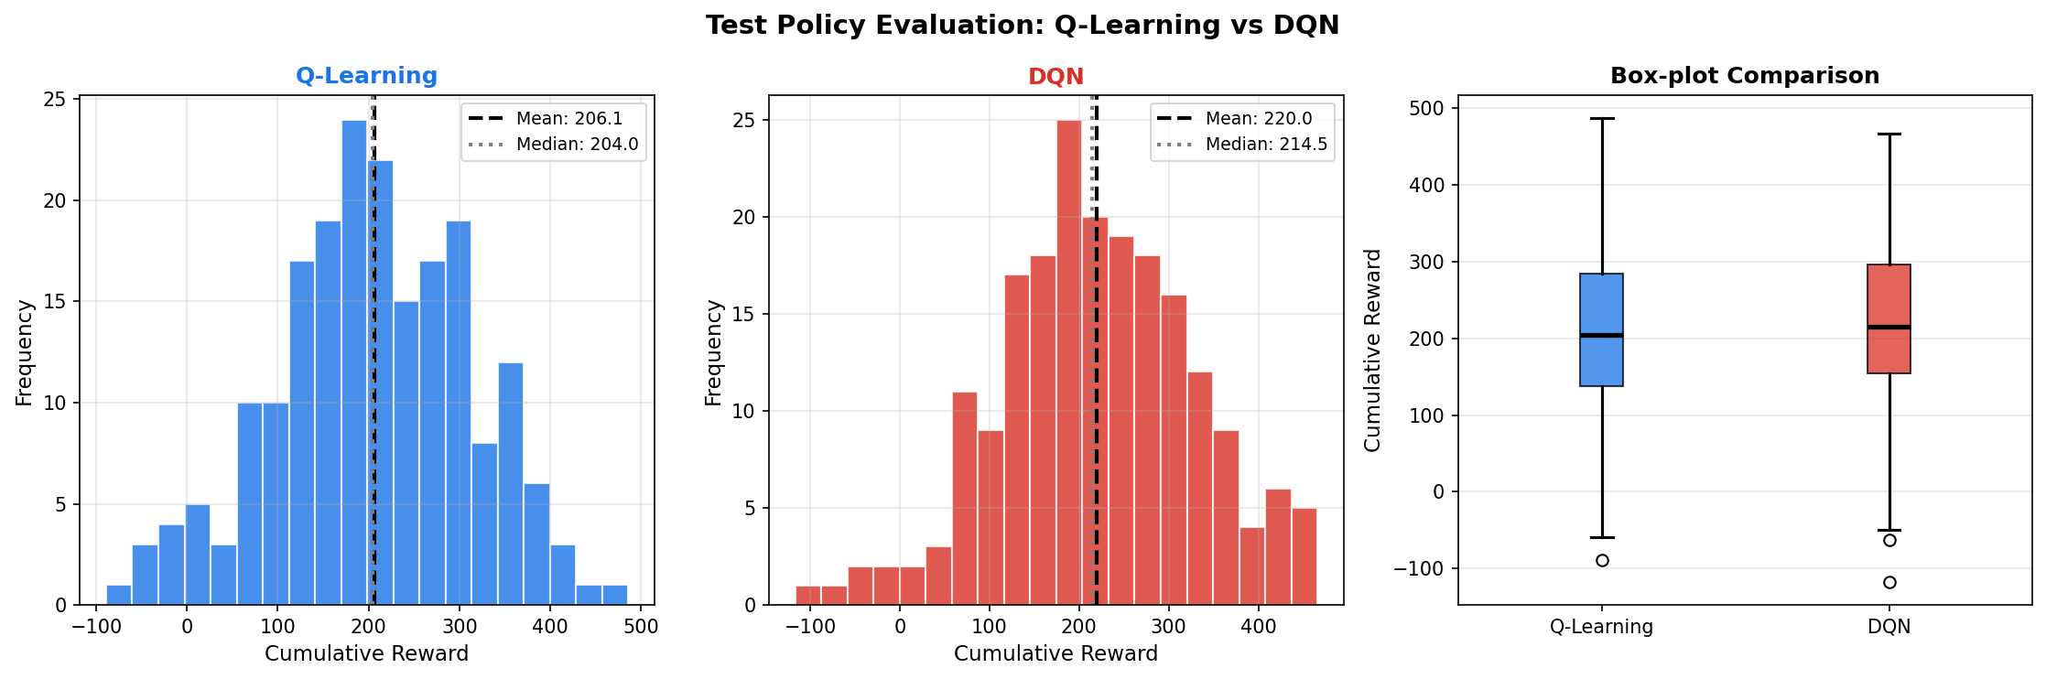
Figure 4. Test reward histograms and box plot: Q-Learning vs DQN (200 evaluation episodes).
Metric | Q-Learning | DQN | Difference
Mean reward | 206.1 | 220.0 | +13.9 (DQN)
Std deviation | 107.4 | 108.7 | ≈ Similar
Median reward | 204.0 | 214.5 | +10.5 (DQN)
Best episode | 486 | 466 | —
Worst episode | -89 | -117 | —

5.3 Policy Heatmap Comparison
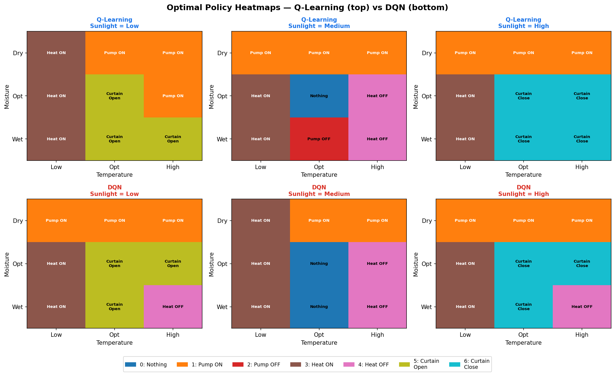
Figure 5. Policy heatmaps for all 27 states: Q-Learning (top) vs DQN (bottom).
Both algorithms learn intuitively correct policies:
- Dry moisture → pump_on (both agree on this critical state)
- Low temperature → heater_on (both agree)
- High temperature → heater_off (both agree)
- Optimal moisture + Optimal temp + Low sun → curtains_open
- Optimal moisture + Optimal temp + Medium sun → do_nothing (conserve resources)
DQN shows slightly more nuanced curtain management due to neural network generalisation across neighbouring states, while Q-Learning shows occasional inconsistencies at boundary states due to insufficient visits during training.
5.4 Overall Summary
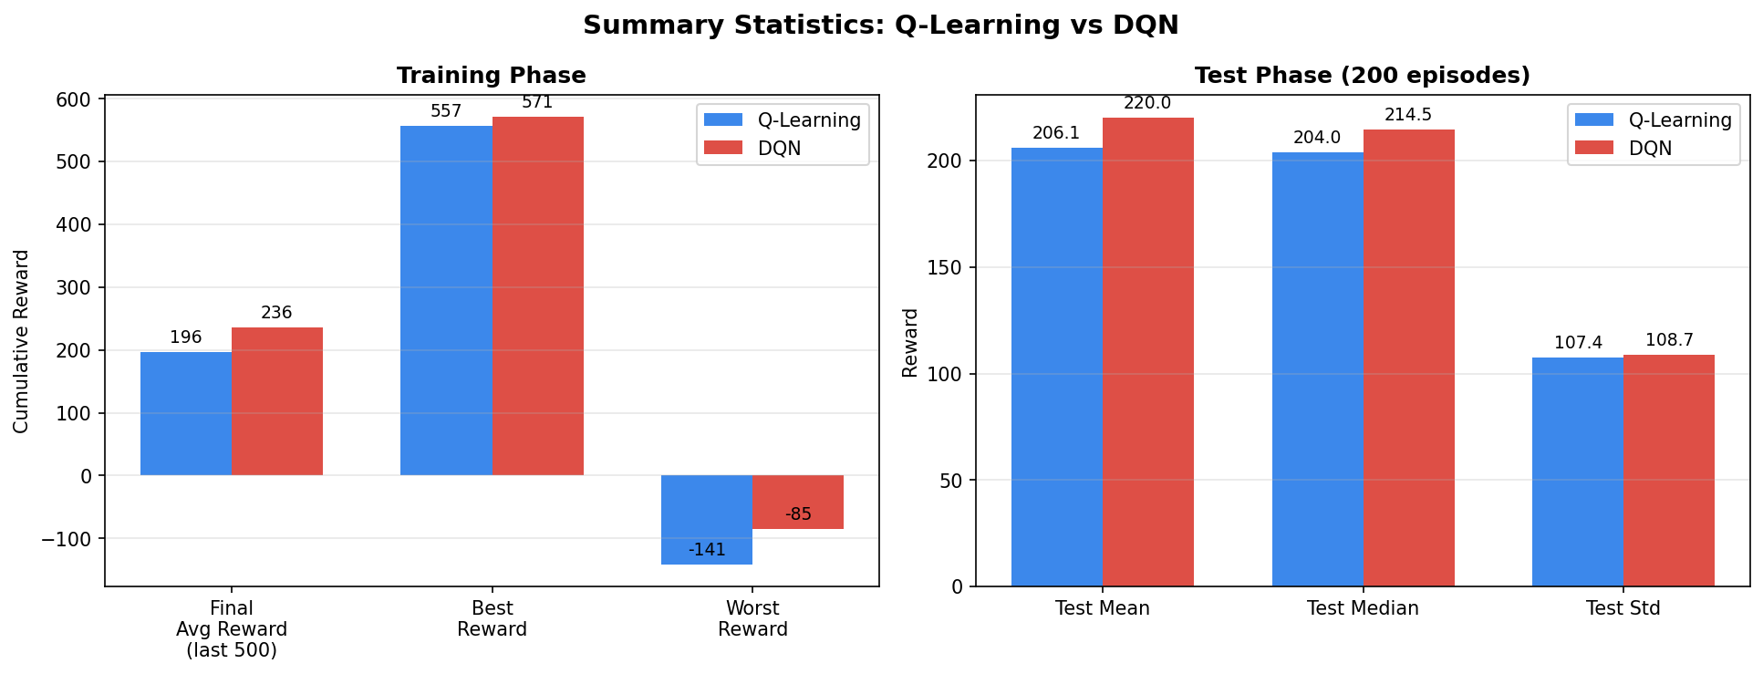
Figure 6. Summary statistics bar chart: training and test performance comparison.
Metric | Q-Learning | DQN | Winner
Train avg reward (last 500 ep) | 196.3 | 236.2 | DQN (+20%)
Train best episode | 557 | 571 | DQN
Test mean reward | 206.1 | 220.0 | DQN (+7%)
Test median reward | 204.0 | 214.5 | DQN (+5%)
Convergence speed | Fast (ep ~2,000) | Slow (ep ~3,000) | Q-Learning
Training time | ~10 sec | ~729 sec | Q-Learning (73× faster)
Memory footprint | 189 floats | ~37,000 params | Q-Learning
Scalability | Poor (27 states only) | Good (continuous states) | DQN

6. Analysis & Discussion
6.1 Why DQN Achieves Higher Final Reward
1. Function Generalisation: DQN shares neural network weights across all states, so learning in (Dry, Low, Low) partially generalises to (Dry, Low, Medium). Q-Learning treats each of the 27 states completely independently.
2. Experience Replay: DQN replays important rare transitions (e.g., critical dry states) multiple times from the buffer. Q-Learning sees each transition exactly once.
3. Aggressive Optimisation: The target network allows Adam (lr=0.001) without oscillation, converging to a better local optimum than Q-Learning's conservative α=0.1.
6.2 Why Q-Learning Converges Faster Initially
1. No warm-up: Q-table updates begin at episode 1; DQN needs ≥64 transitions before the first gradient step.
2. Lower-dimensional optimisation: Updating 189 Q-values is simpler than optimising 37,000 neural network weights in a complex loss landscape.
3. State space advantage: 27 states can be visited exhaustively early in training; DQN's generalisation benefits are minimal at this scale.
6.3 Algorithm Selection Guide
Scenario | Recommended | Reason
Small discrete state space (<1,000) | Q-Learning | Faster, simpler, no GPU needed
Continuous or large state space | DQN | Neural network handles complexity
Resource-constrained IoT device | Q-Learning | Lower compute requirements
Many sensors (CO₂, humidity, pH…) | DQN | Tabular Q-Learning infeasible
Unknown transition dynamics | Both | Both are model-free
Real greenhouse deployment | DQN | Raw sensor data, more sensors, transfer learning

7. Conclusion
This homework successfully implemented DQN for Smart Greenhouse Management and compared it with Q-Learning (HW1) using identical training conditions.
Key findings:
- DQN achieves +7% higher test mean reward (220.0 vs 206.1) and +20% higher final training average (236.2 vs 196.3), demonstrating the benefit of neural function approximation and experience replay.
- Q-Learning converges approximately 73× faster (~10 sec vs ~729 sec) and requires far less memory (189 floats vs 37K parameters), making it preferable for resource-limited IoT deployments with small, well-defined state spaces.
- Both algorithms learn semantically correct greenhouse control policies: prioritising moisture correction (highest penalty) → temperature management → sunlight optimisation.
- For real AIoT greenhouses with raw continuous sensor streams and many environmental variables, DQN is the appropriate choice due to its scalability and generalisation ability.

